Mini Project: Axure Prototype

Name: _Agung Yuda Pratama Cohort: BDSE07-UIF

This is My Axure Prototype of XYZ Tution.

1. **Home Page**

This is The Home Page of XYZ Tution.

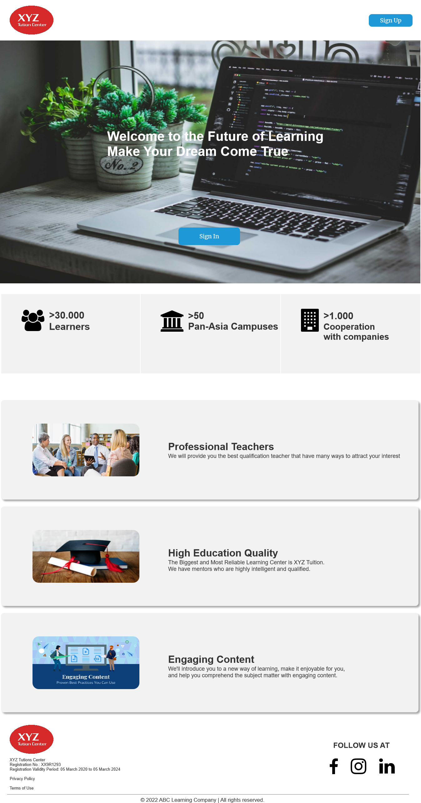

1. **Sign Up Page**

This is The Student Registration page.

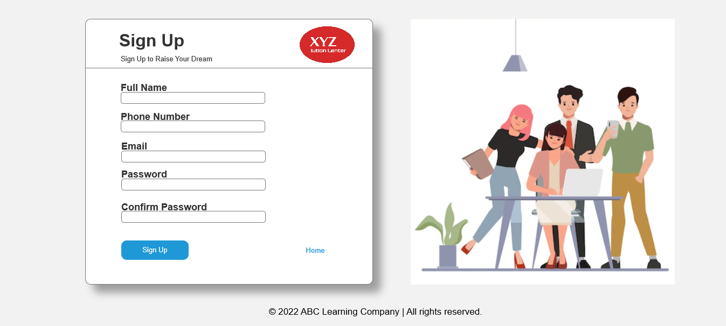

1. **Login Page**

This is The Login Page for students and teachers.

The Teacher’s email is [agung@teacher.com](mailto:agung@teacher.com), and the password is admin123.

The student’s email is [yuda@student.com](mailto:yuda@student.com), and the password is qwerty123.

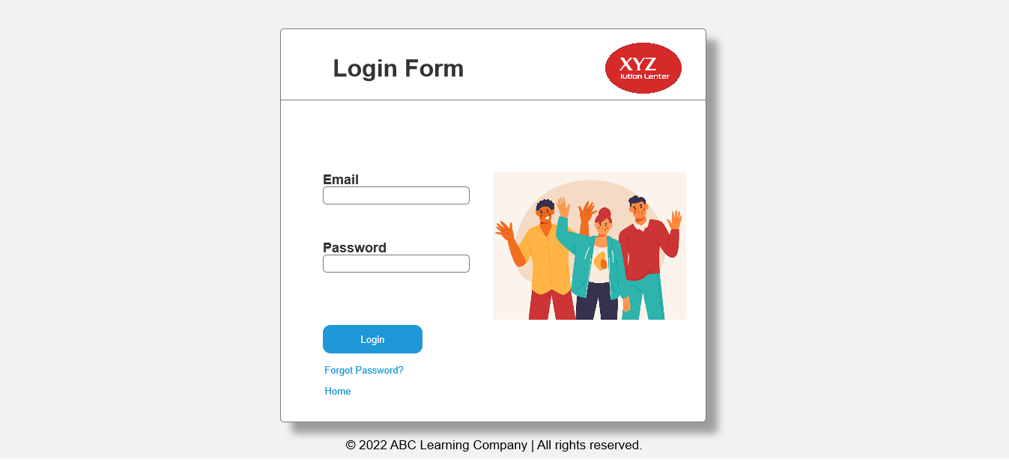

1. **Login Success Page**

After the teacher or student login, they will go to the success page first. Next, click continue button.

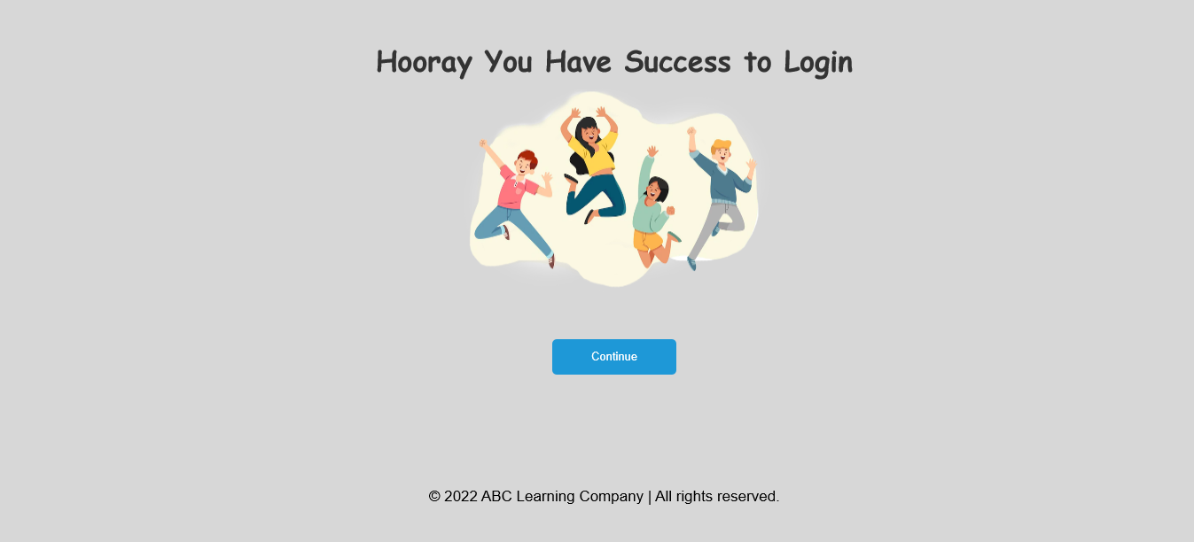

1. **Forgot Password Page**

This is Forgot Password page. If students forget their password, they can change it on this page. Input email first for checking. After that user can change with a new password

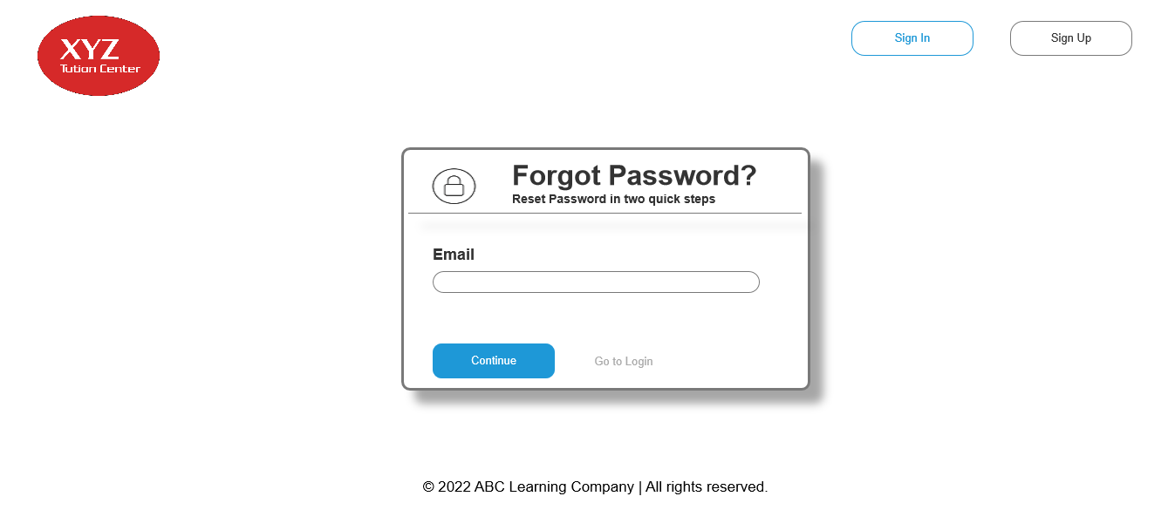

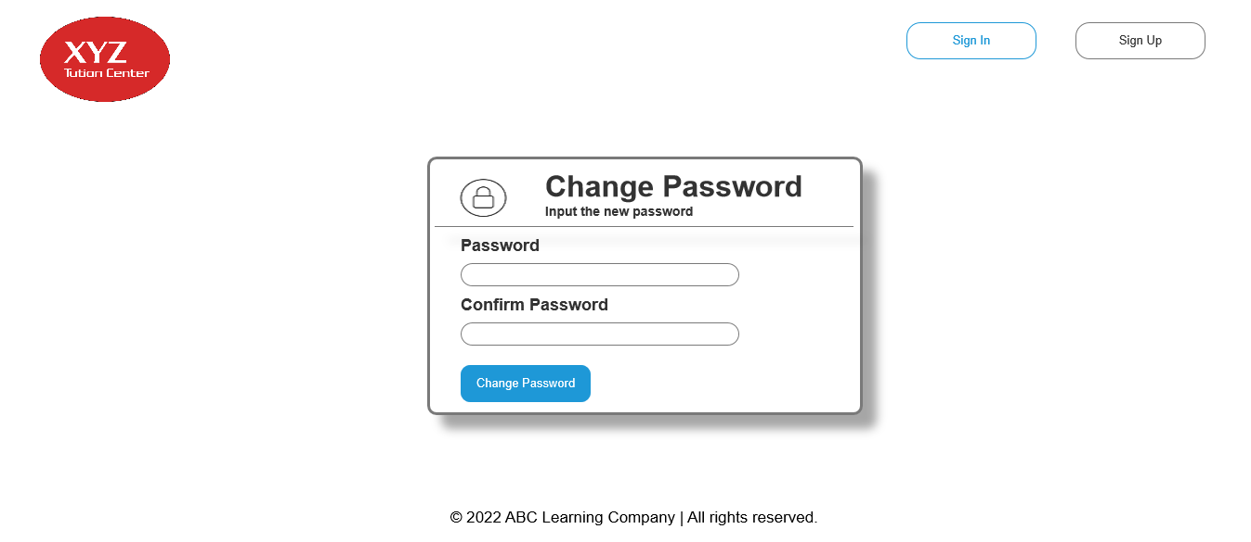

1. **Forgot Password Success Page**

When changing the password success the thank you page will show.

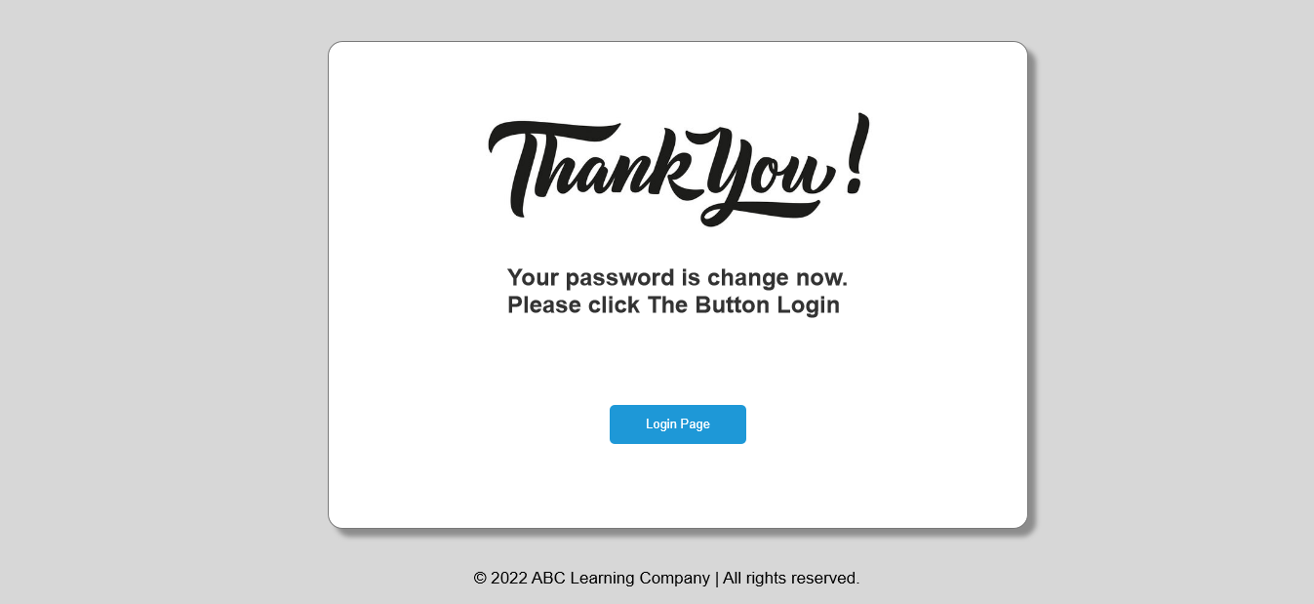

1. **Teacher Dashboard Page**

In the dashboard, the teacher can view all of the courses.

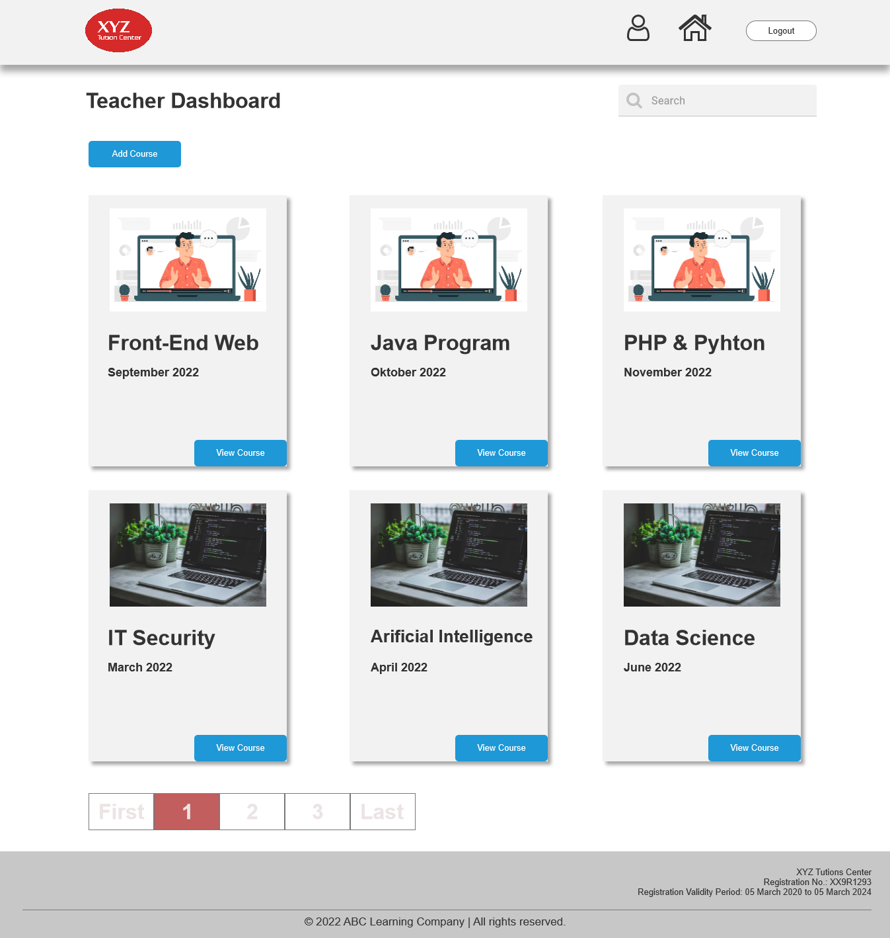

1. **Teacher Content Posting Page**

On this page, teacher can make a new course or materials.

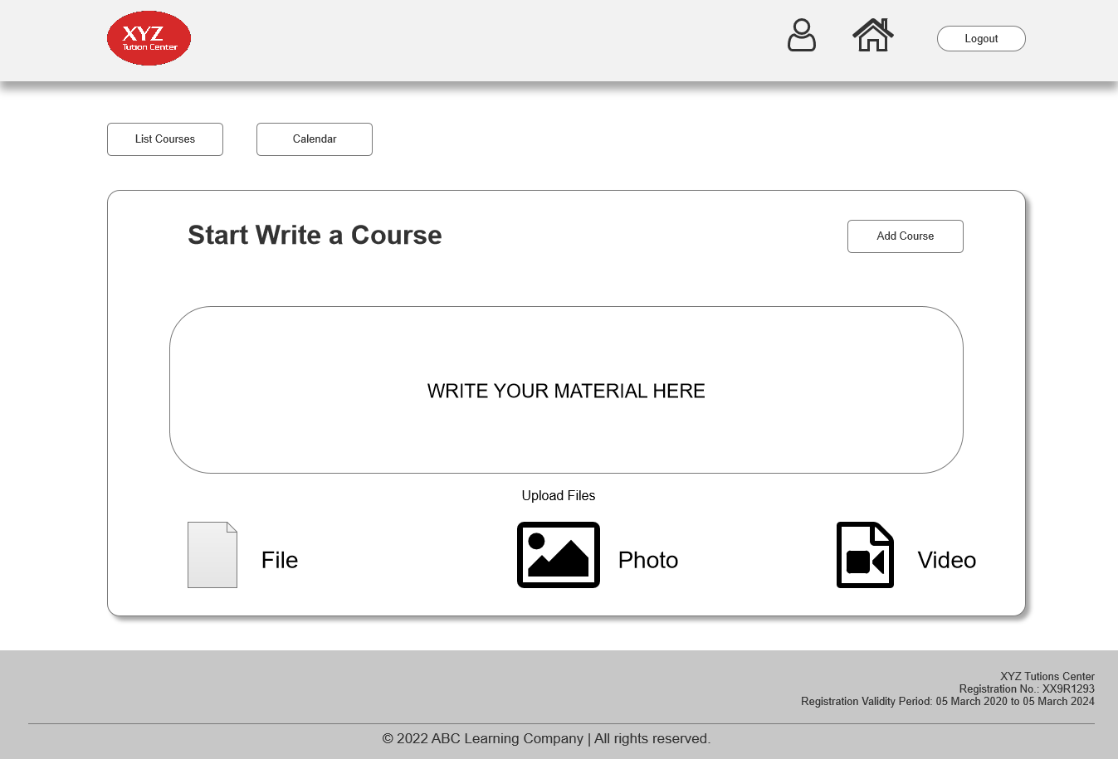

1. **Teacher View Course Page**

On this page teachers can view the content of course and also can add new materials.

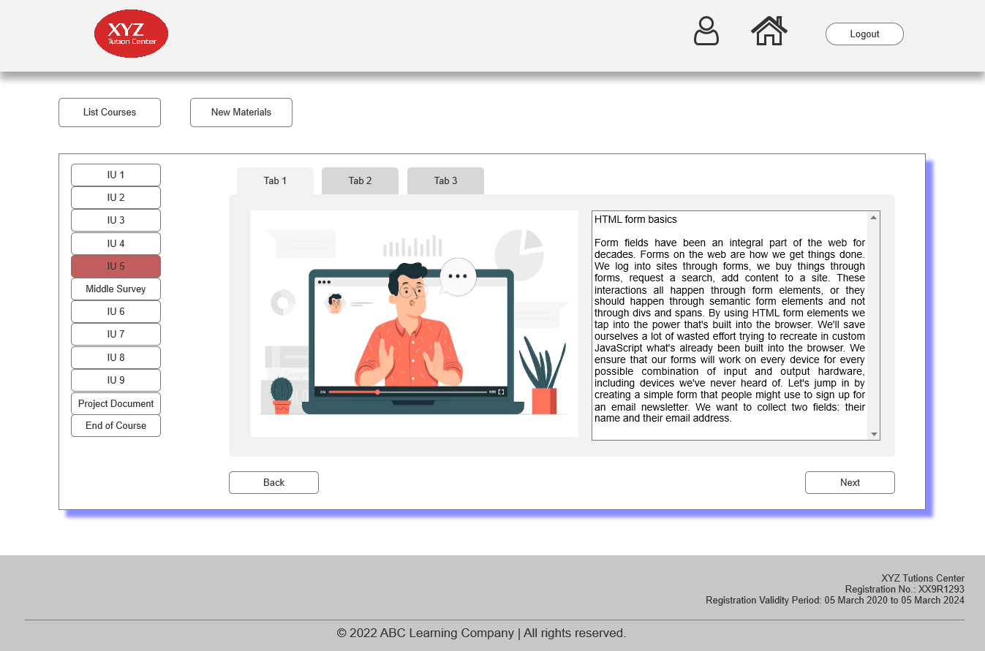

1. **Student Dashboard**

On this page, students can view courses they have and take a look at them.

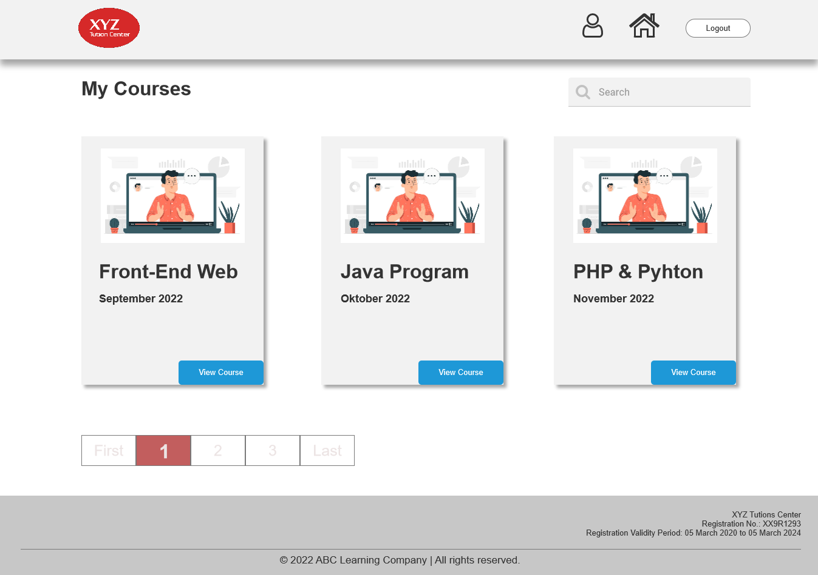

1. **Student View Course Page**

On this page, students can view the material, watch the video, and read the documents.

